Maestro Storyboard Template
May 1, 2020
Proper Face Covering and Glove Use Course

Course description
The COVID-19 pandemic has changed a lot about how we live our lives, from our interactions with others to our daily routines. You can do your part to limit the spread of the coronavirus by doing three important things: maintaining clean hands and wearing face coverings and gloves.

In this self-directed course, learn how to protect yourself and those around you by familiarizing yourself with the CDC’s guidelines for wearing face coverings and gloves. Interactive elements, a video tutorial, and a short assessment will equip you to help limit the spread of the coronavirus.
Course objectives
- Perform the correct hand washing procedures as recommended by the CDC
- Use gloves and face coverings correctly to prevent transmission of COVID-19
- Recall the CDC’s recommendations for different types of face coverings
- Safely put on and remove a face covering
- Safely put on and remove gloves

0. Table of Contents
# | SCREEN TEXT | PRODUCTION / MEDIA NOTES
0.1 | The COVID-19 pandemic has changed a lot about how we live our lives, from our interactions with others to our daily routines. You can do your part to limit the spread of the coronavirus by doing three important things: maintaining clean hands and wearing face coverings and gloves.  Protect yourself and those around you by familiarizing yourself with the CDC’s guidelines for wearing face coverings and gloves.  Review the table of contents below, and then select the “BEGIN” button above to start the course. It should take about 5 minutes to complete. | TABLE OF CONTENTS

1. Hand Washing
# | SCREEN TEXT | PRODUCTION / MEDIA NOTES
1.1 | If there’s one thing you’ve heard a lot lately, it’s probably this: | PARAGRAPH
1.2 | Wash your hands! | STATEMENT
1.3 | While it’s important these days to be extra diligent about washing your hands regularly, it’s crucial that your hands are clean when you’re putting on and taking off face coverings and gloves.  Chances are you’re already a hand washing pro. But let’s review the right technique anyway, just in case. | IMAGE AND TEXT  Hand washing illustration
1.4 | - Wet your hands.  - Apply the soap.  - Working the soap into a lather, scrub your hands for 20 seconds.  - Rinse your hands. | NUMBERED LIST
1.5 | When you wash your hands, you need to hit the obvious spots—and the not-so-obvious ones, too. | PARAGRAPH
1.6A | Palms  This one’s easy. You’re probably not missing this spot! | LABELLED GRAPHIC  HOTSPOT 1  Image/illustration of hands washing
1.6B | Between your fingers  Make sure you get all the nooks and crannies. | HOTSPOT 2  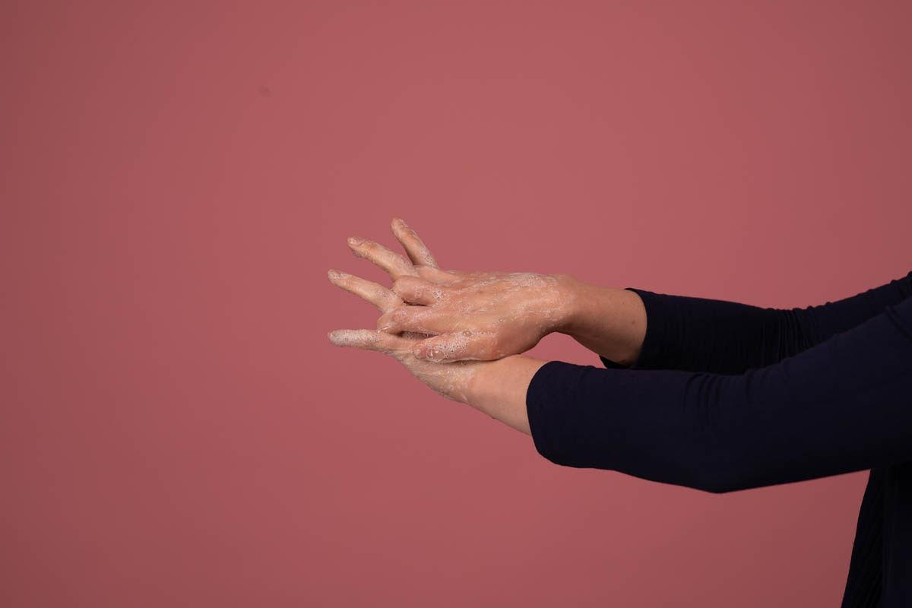
1.6C | The backs of your hands  This one’s easy to forget. The backs of your hands need some love, too! | HOTSPOT 3
1.6D | Under your fingernails  This spot is the hardest to clean, meaning it’s usually the most contaminated part of your hands. Gross! | HOTSPOT 4
1.7 | The CDC’s official recommendation is to sing “Happy Birthday” twice while lathering because the tune is so well-known. But if you get tired of “Happy Birthday,” you can try singing along to any song whose chorus is 20 seconds long while you lather. “Stayin’ Alive” by the Bee Gees and “Somewhere Over the Rainbow” from The Wizard of Oz both work. | IMAGE AND TEXT  Lofty image idea: collage of timer set to 20 seconds, running sink, musical notes
1.8 | Always wash your hands before and after putting on a face covering and gloves. Yeah, that’s a lot of hand washing, but it’s worth it to help limit the spread of the virus. | STATEMENT

2. Face Coverings
# | SCREEN TEXT | PRODUCTION / MEDIA NOTES
2.1 | Why you need a face covering | HEADING
2.2 | Even if you have no symptoms, you can still transmit COVID-19 to others. A face covering might not prevent you from contracting the virus, but it may reduce the risk of the virus spreading to others. | PARAGRAPH  Source: https://www.cdc.gov/coronavirus/2019-ncov/prevent-getting-sick/cloth-face-cover.html
2.3 | Who should wear a face covering? | HEADING
2.4 | With few exceptions, everyone should be wearing a face covering in public spaces where social distancing may be difficult, such as the grocery store. The CDC recommends that face coverings should not be worn by: | PARAGRAPH
2.5 | - Children under the age of two  - People with breathing difficulty  - People who are unconcious or incapacitated  - People who are unable to remove the face covering without assistance | BULLETED LIST
2.6 | Types of face coverings | HEADING
2.7 | There are a few different ways you can cover your face. Here are some that the CDC recommends: | PARAGRAPH
2.8A | N95 respirator  This is a tight-fitting facepiece that filters out 95 percent of both large and small air particles. | ACCORDION  ACCORDION 1  Source: https://www.cdc.gov/niosh/npptl/pdfs/UnderstandDifferenceInfographic-508.pdf
2.8B | Surgical mask  This is a looser-fitting mask that provides protection from large respiratory droplets. | ACCORDION 2
2.8C | Cloth face covering  This is an improvised covering that prevents you from spreading respiratory droplets when you speak, cough, or sneeze. | ACCORDION 3
2.9 | Currently, the CDC recommends that the general public wear only cloth face coverings, leaving N95 respirators and surgical masks for healthcare professionals who are at higher risk of contracting the virus. | PARAGRAPH
2.10 | Approved cloth face coverings | HEADING
2.11 | So, if you shouldn’t wear N95 or surgical masks, what exactly should you wear? The CDC recommends these three types of cloth face coverings: | PARAGRAPH
2.12A | Sewn cloth face covering | IMAGE GRID  IMAGE 1
2.12B | Quick cut T-shirt cloth face covering | IMAGE 2
2.12C | Bandana cloth face covering | IMAGE 3
2.13 | Feeling crafty? You can make all of the above at home with just a few materials! Just follow the step-by-step instructions for creating your own face covering in this printable download. | ATTACHMENT  https://www.cdc.gov/coronavirus/2019-ncov/downloads/DIY-cloth-face-covering-instructions.pdf
2.14 | Features of a great face covering  Time to do a quality check on your face covering. How does yours measure up?  Select each item to see what makes a great face covering. | PARAGRAPH WITH HEADING
2.15A | It has multiple layers of fabric. | LABELLED GRAPHIC  HOTSPOT 1
2.15B | It has ties or ear loops to keep it secure on your face. | HOTSPOT 2
2.15C | It covers your mouth and nose. | HOTSPOT 3
2.15D | It allows you to breathe without restriction. | HOTSPOT 4
2.15E | It maintains its shape after being machine-washed and dried. | HOTSPOT 5
2.16 | Putting on a face covering  There is a correct way to put on your face covering.  Thankfully, it’s pretty straightforward, and by doing it the right way, you protect yourself and those around you. Here are a few things you should remember: | PARAGRAPH WITH HEADING
2.17A | Always wash your hands before putting on the face covering. | THREE COLUMN GRID  GRID IMAGE 1: Handwashing image
2.17B | Secure it around your ears with ties or loops. | GRID IMAGE 2  Mask loops being pulled over ears
2.17C | Make sure it fits snugly and comfortably on the sides of your face. | GRID IMAGE 3  Side shot of mask fitting comfortably on the wearer with his/her arms at side-we might have to ask for this...
2.18 | Things to avoid  If you don’t wear your face covering correctly, you could actually spread the virus without realizing it.  Advance through the images below to see the mistakes you should avoid when wearing a face covering. | PARAGRAPH WITH HEADING
2.19A | Don’t touch the outside of the face covering at all. | CAROUSEL  CAROUSEL 1
2.19B | Don’t touch any part of your face while putting on or removing the face covering. | CAROUSEL 2
2.19C | Don’t pull the face covering down below your chin. | CAROUSEL 3
2.19D | Don’t let the face covering hang loosely on your face. | CAROUSEL 4
2.19E | Don’t fold or bend the face covering while you’re wearing it. | CAROUSEL 5
2.20 | You’ve probably seen one (or more) of the above when out in public. Even so, that doesn’t make it OK!  The good news is that you can be a model of good face covering behavior. | PARAGRAPH
2.21 | Taking off a face covering | HEADING
2.22 | Keep these things in mind when taking off a face covering: | PARAGRAPH
2.23 | - Always wash your hands before removing the face covering.  - Avoid touching your face.  - Remove the covering by grasping only the loops or ties.  - Don’t touch the front of the face covering. | BULLETED LIST
2.24 | Storing your face covering  When it’s time to take your face covering off, you shouldn’t just stuff it into your pocket. Instead, intentionally fold it inward so that the outer, exposed surface is held against itself. This will reduce contact between the outer surface and other areas. Then, carefully place the face covering in a paper bag or breathable container and immediately wash your hands. | PARAGRAPH WITH HEADING
2.25 | Washing your face covering | HEADING
2.26 | The CDC recommends you routinely wash your face covering, depending on how often you use it. The washing machine will work just fine. | PARAGRAPH  Designer, if we decide to include icons maybe a little washing machine here
2.27 | Although you can wash and reuse your cloth face covering, if you’re wearing disposable gloves, you’ll need to carefully remove and replace those. | PARAGRAPH

3. Gloves
# | SCREEN TEXT | PRODUCTION / MEDIA NOTES
3.1 | What you need to know about gloves | HEADING
3.2 | While gloves can provide added protection, it’s important to remember that wearing gloves is not a substitute for hand washing. | PARAGRAPH
3.3 | Every time you replace your gloves, you need to wash your hands as well. | STATEMENT
3.4 | Gloves are great for protecting your hands, but they can actually spread the coronavirus and other germs if you don’t use them properly. That’s why you should avoid touching your face when wearing and replacing gloves, just like you do with face coverings.  Think about all the different objects your hands touch throughout the day! Virus particles on those objects can stick to the outside of your gloves, which is why it’s important to remove your gloves safely, every time. | PARAGRAPH  Designer, maybe some smaller icons in between these two paragraphs of different items that might be touched throughout the day with a little virus on them? Laptops, sink handles, phones, etc….
3.5A | How to remove your gloves  Advance through the steps of proper glove removal. | PROCESS INTRO
3.6B | Grasp the outside of one glove at your wrist by pinching it in between your fingers. Be careful not to touch any bare skin. | PROCESS STEP 1  IMAGE: I imagined using still photos from the shoot for these but it might be unnecessary. Could easily become a timeline with no images.
3.6C | Peel the glove away from your body, pulling it inside-out as you go. | PROCESS STEP 2
3.6D | Hold onto the glove you just removed in your gloved hand. | PROCESS STEP 3
3.6E | Remove the second glove by sliding your finger inside the glove at the top of your wrist, being careful not to touch the outside of the glove. This part is a little tricky, but you’ll get it with some practice! | PROCESS STEP 4
3.6F | Turn the second glove inside out as you pull it away from your body, keeping the first glove contained inside the second. | PROCESS STEP 5 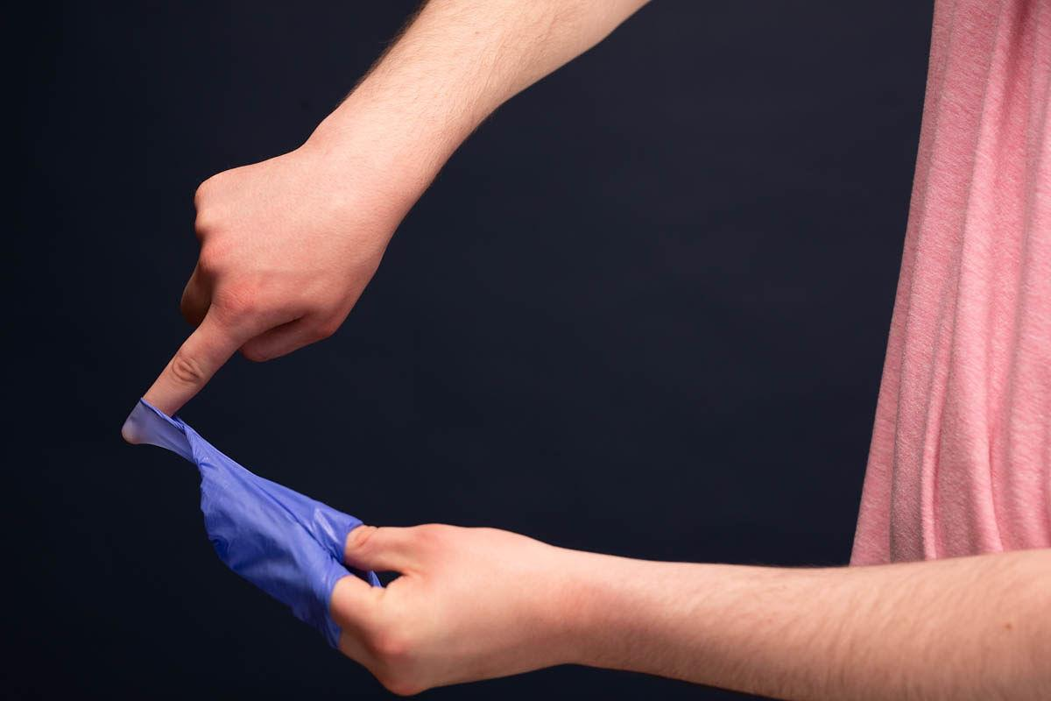
3.6G | Safely dispose of both gloves right away. | PROCESS STEP 6
3.6H | Immediately wash your hands. | PROCESS STEP 7
3.7 | When to replace your gloves  Now that you know the right way to remove your gloves, how often should you replace them?  Follow these guidelines: | PARAGRAPH WITH HEADING  ILLUSTRATION: torn or dirty gloves?
3.8 | - Replace your gloves when switching tasks to avoid transferring germs from one area or object to another.  - Replace gloves that are dirty, punctured, or torn. | BULLETED LIST
3.9 | We’ve broken down the steps for proper face covering and glove usage, and now it’s time to put it all together! | PARAGRAPH

4. Face Coverings and Gloves: Step by Step
# | SCREEN TEXT | PRODUCTION / MEDIA NOTES
4.1 | See all the best practices come together in the video below. | PARAGRAPH
4.2 |  | VIDEO
4.3 | Phew! That’s a lot of steps to remember, so we’ve broken down the process for you in a printable download. Hang it up in your home or workplace to help you perform all the right steps when putting on and taking off your face covering and gloves. | ATTACHMENT  https://www.cdc.gov/coronavirus/2019-ncov/hcp/using-ppe.html
4.4 | Coming up next  You’ve learned a lot, and it’s time to show it. Continue on for a short assessment you need to take before exiting the course. You’ve got this! | PARAGRAPH WITH HEADING

5. Assessment
# | SCREEN TEXT | PRODUCTION / MEDIA NOTES
5.0 | It’s time to check your knowledge of proper face covering and glove use. This final assessment consists of 6 questions. Read each question carefully and choose the best available answer(s).  After completing the assessment, you’ll automatically receive your score. You must receive a score of 100% to complete the course. If you don’t receive a passing score, you can repeat the course and the assessment until you do pass. | ASSESSMENT INTRO TEXT
5.1 | How long should you wash your hands with soapy water?  - 5 seconds  - 10 seconds  - 20 seconds | ASSESSMENT QUESTION 1
5.2 | image 45  Is this person wearing his face covering correctly?  - Yes  - No | ASSESSMENT QUESTION 2
5.3 | 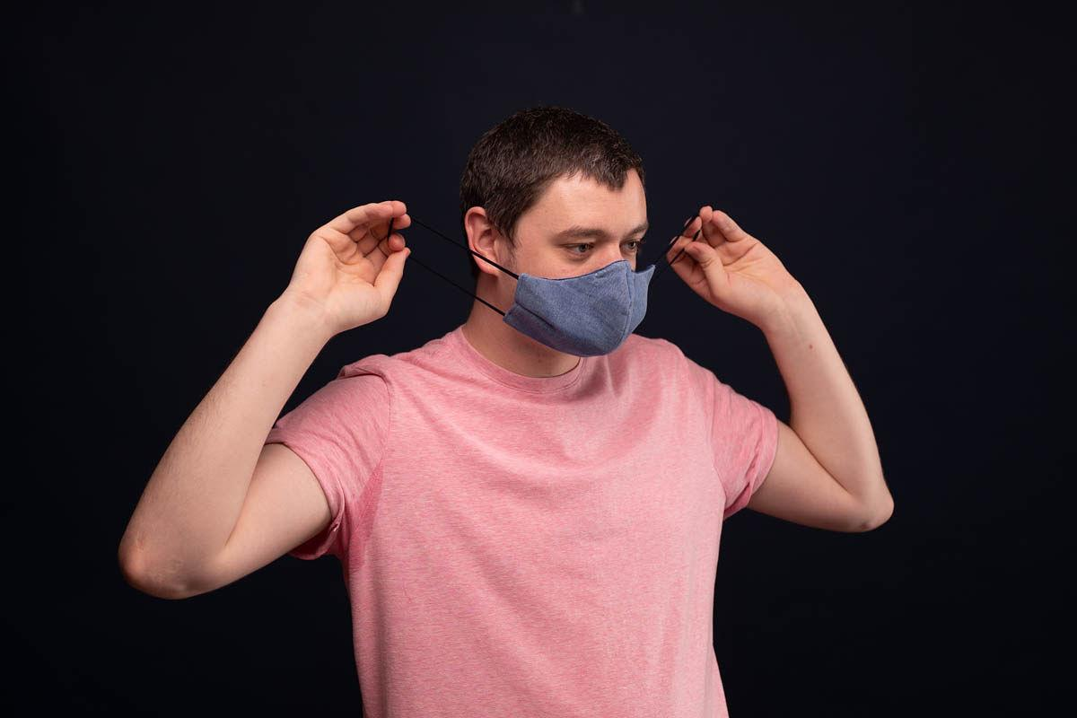  image 110  Is this person removing his face covering correctly?  - Yes  - No | ASSESSMENT QUESTION 3
5.4 | You’re wearing a face covering and gloves, and it’s time for you to take them off. Which of the following actions should come first?  - Remove your gloves  - Remove your face covering  - Wash your hands | ASSESSMENT QUESTION 4
5.5 | You’ve removed one of your gloves and now it’s time to remove the other. What is the first step in removing the second glove?  - Grasp the glove on the outside near your wrist by pinching it between your fingers  - Grasp the glove in the middle of your palm  - Slide your finger inside the glove at the top of your wrist, being careful not to touch the outside of the glove | ASSESSMENT QUESTION 5
5.6 | Is wearing gloves an effective substitute for hand washing?  - Yes  - No | ASSESSMENT QUESTION 6

6. Summary
# | SCREEN TEXT | PRODUCTION / MEDIA NOTES
6.1 | Congratulations! | HEADING
6.2 | You passed the assessment. Excellent work!  When it comes to wearing face coverings and gloves, the details are small, but they’re important. You never know what impact your actions will have. And remember, always stay up-to-date with CDC guidelines. | PARAGRAPH
6.3 |  | BUTTON  Text: CDC.gov
6.4 | One last thing…  In order to help us improve our course offerings, please leave us some feedback on this course before you exit. | PARAGRAPH
6.5 |  | TYPEFORM SURVEY
6.6 | Thanks for your time and attention. Be sure to select the “EXIT COURSE” button in order to get credit for completion. | PARAGRAPH
6.7 | Exit course | BUTTON
6.8 | References  Centers for Disease Control and Prevention. “Use of Cloth Face Coverings to Help Slow the Spread of COVID-19.” 2020. https://www.cdc.gov/coronavirus/2019-ncov/downloads/DIY-cloth-face-covering-instructions.pdf  Centers for Disease Control and Prevention. “How to Remove Gloves.” https://www.cdc.gov/vhf/ebola/pdf/poster-how-to-remove-gloves.pdf  “Prevent Getting Sick.” Coronavirus Disease 2019 (COVID-19). Centers for Disease Control and Prevention, April 8, 2020. https://www.cdc.gov/coronavirus/2019-ncov/prevent-getting-sick/index.html  “Information for Healthcare Professionals about Coronavirus (COVID-19).” Coronavirus Disease 2019 (COVID-19). Centers for Disease Control and Prevention, May 5, 2020. https://www.cdc.gov/coronavirus/2019-nCoV/hcp/index.html  “Healthcare Providers.” Hand Hygiene in Healthcare Settings. Center for Disease Control and Prevention, January 31, 2020. https://www.cdc.gov/handhygiene/providers/index.html | PARAGRAPH
6.9 | Legal disclaimers  While this course contains valuable information and applies to many working environments, it’s not all-inclusive. Please use your employer’s guidelines and your existing knowledge in your workplace to keep yourself, your work environment, and your company safe.  The content of this course, including documentation, is owned by Maestro, LLC and is protected by copyright laws and international copyright treaties. Disclosure, copying, reproduction, merger, translation, modification, or enhancement of this course or any portion is expressly prohibited.  This course was created with love by Maestro. ❤️ | ACCORDION

